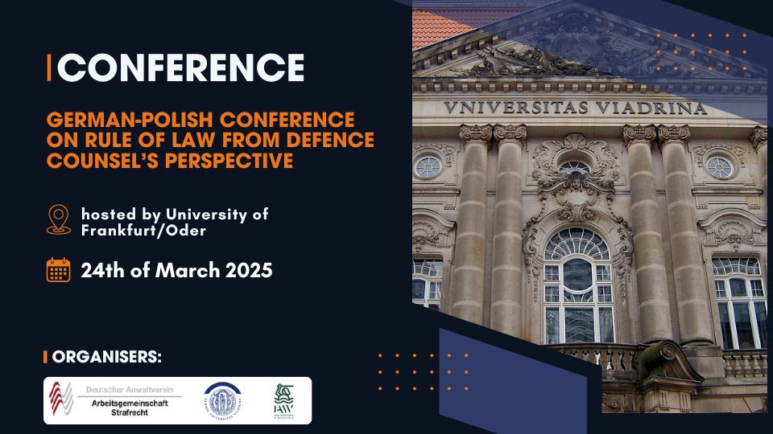

**German-Polish Conference on Rule of Law from defense counsel’s perspective**

The Criminal Law Section of the German Bar Association, the Warsaw Bar Association and the University of Frankfurt/Oder invite you to the German-Polish Conference on Rule of Law from defense counsel’s perspective.

**Date**: 24th of March 2025

**Venue:** University of Frankfurt/Oder, Logensaal, Große Scharrnstraße 59, D-15230 Frankfurt, Oder

**Framework programme:**

**10:00 am** Welcome words by representatives of

Criminal Law Section of the German Bar Association

Warsaw Bar Association

University Frankfurt Oder

**10:30 am** Rule of Law – concrete topic(s) to be finalised in May 2024 latest depending on developments in Poland

**11:30 am** Rights of suspects/ suspects warnings – access to criminal case file – defence rights including client-attorney-privilege

**12:30 pm** Lunch Break

**01:30 pm** Examples of cross-border cases involving joint investigation teams (JITs) and/or European Public Prosecutor’s Office (EPPO)

**02:30 pm** German-Polish money laundering cases – case studies

**04:00 pm** Closing Remarks

**04:30 pm** Reception

**06:00 pm** End of conference

**The conference will be held in English. No conference fee!**

*Other detailed information will be provided on a later date.*

**Registration via e-mail to e-mail-account by until February 15, 2025:** [**ludmila.wolynska@ora-warszwa.com.pl**](mailto:ludmila.wolynska@ora-warszwa.com.pl)